**Comprehensive Digital Learning System for**

**Students**



A

Project Report

Submitted in partial fulfillment of the requirement for the award of degree of

**Bachelor of Technology**

In

**Information Technology**

Submitted to

**RAJIV GANDHI PROUDYOGIKI VISHWAVIDYALAYA,**

**BHOPAL (M.P.)**

**Guided By Submitted By**

Prof. Mahendra Verma Harsh Suryavanshi (0827IT221056)

**DEPARTMENT OF INFORMATION TECHNOLOGY**

**ACROPOLIS INSTITUTE OF TECHNOLOGY & RESEARCH,**

**INDORE (M.P.) 452020**

**2024-2025**

# Declaration

I hereby declared that the work, which is being presented in the project entitled **Comprehensive Digital Learning System for Students** partial fulfillment of the requirement for the award of the degree of **Bachelor of Technology**, submitted in the department of Information Technology at **Acropolis Institute of Technology & Research, Indore** is an authentic record of my own work carried under the supervision of “**Prof. Mahendra Verma**”. I have not submitted the matter embodied in this report for the award of any other degree.

Harsh Suryavanshi (0827IT221056)

Prof. Mahendra Verma

Supervisor

# Project Approval Form

I hereby recommend that the project Comprehensive Digital Learning System for Students prepared under my by supervision by Harsh Suryavanshi (0827IT221056) be accepted in partial fulfillment of the requirement for the degree of Bachelor of Technology in Information Technology

Prof. Mahendra Verma

**Supervisor**

Recommendation concurred in 2024-2025

Prof. Monika Choudhary

**Project Incharge**

Prof. Deepak Singh Chouhan

**Project Coordinator**

**Acropolis Institute of Technology & Research**

# Department of Information Technology



# Certificate

The project work entitled Comprehensive Digital Learning System for Students submitted by Harsh Suryavanshi (0827IT221056) is approved as partial fulfillment for the award of the degree of Bachelor of Technology in Information Technology by Rajiv Gandhi Proudyogiki Vishwavidyalaya, Bhopal (M.P.).

**Internal Examiner External Examiner**

Name:………………. Name: ……………..

Date: …./…/……….. Date: …./…/………..

# Acknowledgement

With boundless love and appreciation, I would like to extend our/my heartfelt gratitude and appreciation to the people who helped us/me to bring this work to reality. I would like to have some space of acknowledgement for them.

Foremost, I would like to express my sincere gratitude to our/my supervisor, **Prof. Mahendra Verma** whose expertise, consistent guidance, ample time spent and consistent advice that helped us/me to bring this study into success.

To the project in-charge **Prof. Monika Choudhary** and project coordinator **Prof. Deepak Singh Chouhan** for their constructive comments, suggestions, and critiquing even in hardship.

To the honorable **Prof. (Dr.) Prashant Lakkadwala**, Head, Department of Information Technology for his favorable responses regarding the study and providing necessary facilities.

To the honorable **Dr. S.C. Sharma**, Director, AITR, Indore for his unending support, advice and effort to make it possible.

Finally, I would like to pay my thanks to faculty members and staff of the Department of Computer Science & Engineering for their timely help and support.

We/I also like to pay thanks to my **parents** for their eternal love, support and prayers without them it is not possible.

# Abstract

The "Comprehensive Digital Learning System for Students" aimed to create a holistic platform to improve education, addressing the growing demand for accessible, flexible learning tools, especially due to the shift to online education during the COVID-19 pandemic.

**1. What was done?**

A digital learning platform was created, integrating various educational resources such as interactive lessons, multimedia content, and assessment tools into a single, user-friendly interface.

1. **Why was it done?**

The project was initiated to address the need for modern, adaptable, and effective educational tools that can cater to diverse learning styles and enhance student engagement and comprehension in a digital learning environment.

1. **How was it done?**

The development process included research, system design, coding, testing, and improvements based on user feedback. AI and machine learning were used to personalize learning, while collaborative tools enhanced communication and teamwork.

**4.What was found?**

The digital learning system led to improved student engagement and comprehension, with higher test scores and positive feedback. Its real-time feedback and adaptability were key to its success. Educators also found the platform streamlined their workflow, allowing more focus on teaching.

**5. What is the significance of the findings?**

These findings highlight the potential of a comprehensive digital learning system to revolutionize education by offering a flexible, personalized, and engaging environment. This project emphasizes the importance of technology in creating inclusive, effective solutions, improving education quality and accessibility globally.

# Table of Content

**Declaration …………………………………………………………………………** II

**Project Approval Form ……………………………………………………………** III

**Acknowledgement …………………………………………………………………** V

**Abstract ……………………………………………………………………………** VI **List of Figures……………………………………………………………………...** XI

**List of Tables………………………………………………………………………** XIII

**Abbreviations……………………………………………………………………...** XIV

**Chapter 1: Introduction**

1.1 Rationale ……………………………………………………………….. XIV

1.2 Existing System ………………………………………………………... XIV

1.3 Problem Formulation………………………………………………....... XIV

1.4 Proposed System……………………………………………………….. XIV

1.5 Objectives……………………………………………………………… XIV

1.6 Contribution of the Project…………………………………………….. XV

1.6.1 Market Potential…………………………………………....... XV

1.6.2 Innovativeness………………………………………….......... XV

1.6.3 Usefulness…………………………………………............... XV

1.7 Report Organization……………………………………………………. XV

**Chapter 2: Requirement Engineering**

2.1 Feasibility Study (Technical, Economical, Operational)……………..... XVII

2.2 Requirement Collection………………………………………………... XVII

2.2.1 Discussion………………………………………………..….. XVII

2.2.2 Requirement Analysis………………………………………. XVII

2.3 Requirements………………………………………………………….. XVIII

2.3.1 Functional Requirements………………………………….. XVIII

2.3.1.1 Statement of Functionality………………………... XVIII

2.3.2 Nonfunctional Requirements……………………………….. XIX

2.3.2.1 Statement of Functionality………………………... XIX

2.4 Hardware & Software Requirements…………………………………. XX

2.4.1 Hardware Requirement (Developer & End User)…………... XX

2.4.2 Software Requirement (Developer & End User)..………….. XX

2.5 Use-case Diagrams……………………………………………………. XXI

2.5.1 Use-case Descriptions………………………………………. XXI

**Chapter 3: Analysis & Conceptual Design & Technical Architecture……….** XXII

3.1 Technical Architecture……………………………………………. XXII

3.2 Sequence Diagrams………………………………………………. XXIII

3.3 Class Diagrams……………………………………………………. XXIV

3.4 DFD……………………………………………………………….. XXV

3.5 User Interface Design……………………………………………. XXV

3.6 Data Design………………………………………………………. XXVI

3.6.1 Schema Definitions………………………………………… XXVI

3.6.2 E-R Diagram……………………………………….. XXVI

**Chapter 4: Implementation & Testing………………………………………..** XXVII

4.1 Methodology……………………………………………………. XXVII

4.1.1 Proposed Algorithm………………………………… XXVII

4.2 Implementation Approach……………………………………… XXVII

4.2.1 Introduction to Languages, IDEs Tools and Technologies…. XXVII

4.3 Testing Approaches…………………………………………………… XXVIII

4.3.1 Unit Testing…………………………………………………. XXVIII a. Test Cases………………………………………………. XXVIII

4.3.2 Integration Testing………………………………………….. XXIX

b. Test Cases ……………………………………………... XXIX

**Chapter 5: Results & Discussion…………………………………………………** XXX

5.1 User Interface Representation…………………………………………. XXX

5.1.1 Brief Description of Various Modules………………………. XXXI

5.2 Snapshot of System with Brief Description………………………….. XXXII

5.3 Database Description………………………………………………….. XXXII

5.3.1 Snapshot of Database Tables with Brief Description……….. XXXII

5.4 Final Findings…………………………………………………………. XXXIII

1. **Conclusion & Future Scope……………………………………………………** XXXIV
   1. Conclusion………………………………………………………...…... XXXIV
   2. Future Scope………………………………………………………. XXXIV **REFERENCES……………………………………………………………….** XXXV

**Appendix A:** Project Synopsis………………………………………………. XXXVII **Appendix B:** Guide Interaction Report ……………………………………… XXXVII **Appendix C:** User Manual ……….…………………………………………. XXXVII

**Appendix D:** Git/GitHub Commits/Version History………. ………………. XXXVII

# List of Figures

* **Figure 1**: High-Level System Architecture Diagram

Description: Overview of the overall architecture and components of the digital learning system.

* **Figure 2**: User Interface Wireframes

Description: Design mock-ups of the main user interfaces, including login screen, dashboard, and course pages.

* **Figure 3**: Data Flow Diagram (DFD) - Level 0

Description: Context-level diagram showing the major processes and data flows in the system.

* **Figure 4**: Data Flow Diagram (DFD) - Level 1

Description: Detailed DFD showing the breakdown of main processes into sub-processes.

* **Figure 5**: Entity-Relationship (ER) Diagram

Description: Database schema illustrating the relationships between different entities in the system.

* **Figure 6**: Use Case Diagram

Description: Diagram showing the different use cases and interactions between users and the system.

* **Figure 7**: Sequence Diagram for User Login

Description: Step-by-step sequence of interactions during the user login process.

* **Figure 8**: Class Diagram

Description: Diagram representing the classes and relationships in the system’s software design.

* **Figure 9**: Deployment Diagram

Description: Visual representation of the deployment architecture, including servers and software components.

* **Figure 10**: Activity Diagram for Course Enrollment

Description: Flowchart showing the steps involved in enrolling a student in a course.

* **Figure 11**: Screenshot of the Dashboard Interface

Description: Screenshot of the main dashboard that users see upon logging in.

* **Figure 12**: Performance Metrics Graph

Description: Graph showing key performance metrics such as system response time and user engagement rates.

* **Figure 13**: Testing Results Summary

Description: Summary of testing results, including bug reports and performance benchmarks.

# List of Tables

**Table 1**: Functional Requirements

Description: Detailed list of all functional requirements of the digital learning system.

**Table 2**: Non-functional Requirements

Description: Detailed list of all non-functional requirements such as performance, security, and usability.

# Abbreviations

## Chapter 1: Introduction

### 1.1 Rationale

The rapid shift to digital education due to the COVID-19 pandemic highlighted the need for an effective digital learning system. This project aims to develop a platform that addresses the diverse learning needs of students, enhancing accessibility, flexibility, and engagement in education.

### 1.2 Existing System

Many current digital learning systems offer fragmented and inconsistent experiences, lacking personalization and comprehensive integration of educational resources. These limitations hinder student engagement and learning outcomes.

### 1.3 Problem Formulation

The main problem is the need for a unified digital learning platform that integrates interactive lessons, multimedia content, assessment tools, and collaborative features while personalizing the learning experience for each student.

### 1.4 Proposed System

The proposed system is a comprehensive digital learning platform that leverages advanced technologies such as AI and machine learning to provide a personalized, engaging, and effective learning experience. It integrates various educational resources and tools into a single, user-friendly interface.

### 1.5 Objectives

* Develop an interactive digital learning platform.
* Integrate multimedia content, assessment tools, and collaborative features.
* Personalize the learning experience using AI and machine learning.
* Enhance student engagement and learning outcomes.

### 1.6 Contribution of the Project

**1.6.1 Market Potential:** The system has significant market potential due to the growing demand for digital learning solutions, especially in the postpandemic era. It addresses the needs of students, educators, and educational institutions.

**1.6.2 Innovativeness:** The use of AI and machine learning for personalization, along with the integration of diverse educational resources and collaborative tools, makes this system innovative. It stands out by providing a cohesive and adaptive learning environment.

**1.6.3 Usefulness:** The platform is useful for both students and educators. Students benefit from a personalized and engaging learning experience, while educators can utilize the system to enhance teaching efficiency and effectiveness.

### 1.7 Report Organization

This report is organized as follows:

* **Chapter 1**: Introduction – Overview and objectives of the project.
* **Chapter 2**: Literature Review – Analysis of existing systems and technologies.
* **Chapter 3**: System Requirements – Detailed functional and non-functional requirements.
* **Chapter 4**: System Design – Design architecture, modules, and interfaces.
* **Chapter 5**: Implementation – Development process, tools, and technologies used.
* **Chapter 6**: Testing – Testing methodologies, test cases, and results.
* **Chapter 7**: Deployment – Steps and configurations for deploying the system.
* **Chapter 8**: User Manual – Instructions for using the system.
* **Chapter 9**: Conclusion – Summary, achievements, challenges, and future work.
* **References**: List of references and sources used in the project.
* **Appendices**: Additional materials such as questionnaires and raw data.

## Chapter 2: Requirement Engineering

### 2.1 Feasibility Study

**Technical Feasibility:**

* Assessment of the technical resources required for the project.
* Evaluation of existing technology and tools.
* Determination of the system's compatibility with current infrastructure.

**Economical Feasibility:**

* Cost-benefit analysis of developing and deploying the system.
* Estimation of development costs, operational costs, and potential savings.

**Operational Feasibility:**

* Evaluation of the system's ability to meet user needs.
* Assessment of the operational workflow and user acceptance.
* Identification of potential operational challenges and mitigation strategies.

### 2.2 Requirement Collection

**2.2.1 Discussion:**

* Meetings with stakeholders to gather requirements.
* Conducting surveys and interviews with potential users.
* Reviewing existing systems and identifying gaps.

**2.2.2 Requirement Analysis:**

* Categorizing and prioritizing requirements.
* Creating detailed requirement specifications.
* Validating requirements with stakeholders.

### 2.3 Requirements

**2.3.1 Functional Requirements:**

* **Statement of Functionality:**
  + The system should provide interactive lessons and multimedia content. o The system should offer assessment tools for quizzes and tests.
  + The system should facilitate communication and collaboration among students and educators.
  + The system should track student progress and provide personalized feedback.

|  |  |  |  |
| --- | --- | --- | --- |
| **Requirement ID** | **Description** | **Priority** | **Remarks** |
| FR1 | User registration and login system. | High | Include email verification and role based access. |
| FR2 | Upload, down, and share study notes | High | Supports various file formats. |
| FR3 | Search and filter functionality for notes | High | Include keywords search, tag. |
| FR4 | Peer review and rating system | Medium | Allow users to rate and review notes with assurance. |
| FR5 | Note recommendation based on user preference. | Medium | Uses AI to suggest relevant matrials. |

**2.3.2 Non-functional Requirements:**

* **Statement of Functionality:**
  + The system should be scalable to handle increasing numbers of users.
  + The system should ensure data security and privacy. o The system should have high availability and minimal downtime.
  + The system should be user-friendly and accessible on various devices.

|  |  |  |  |
| --- | --- | --- | --- |
| **Requirement ID** | **Description** | **Priority** | **Remarks** |
| NFR1 | System performance | High | Must handle at least 1,000 concurrent users without lag. |
| NFR2 | Security | High | Includes data encryption and  secure authentication. |
| NFR3 | Usability | High | User-friendly UI with minimal learning curve. |
| NFR4 | Scalability | High | System must scale to accommodate growth in users and data. |

### 2.4 Hardware & Software Requirements

**2.4.1 Hardware Requirement (Developer & End User):**

* **Developer:**
  + - * High-performance computers for development and testing.
      * Servers for hosting the development environment.
* **End User:**
  + - * Desktop or laptop computers with internet connectivity.
      * Mobile devices (optional) for accessing the system on-the-go.

**2.4.2 Software Requirement (Developer & End User):**

* **Developer:**
  + - * Integrated Development Environment (IDE) like Visual Studio Code or IntelliJ IDEA.
      * Database management system (e.g., MySQL, PostgreSQL).
      * Project management tools (e.g., JIRA, Trello).
* **End User:**
  + - * Web browsers (e.g., Google Chrome, Mozilla Firefox).
      * Access to the system's web application.

**2.5 Use-case Diagrams**

**2.5.1 Use-case Descriptions:**

* **User Login:**

o Users can log in using their credentials.

* **Access Courses:** o Students can browse and access available courses.
* **Take Assessments:** o Students can take quizzes and exams provided in the system.
* **Submit Assignments:** o Students can upload their assignments.
* **View Progress:**

o Students and educators can track academic progress and performance.

* **Collaborate:**

o Users can participate in discussion forums and group activities.

## Chapter 3: Analysis & Conceptual Design & Technical Architecture

### 3.1 Technical Architecture

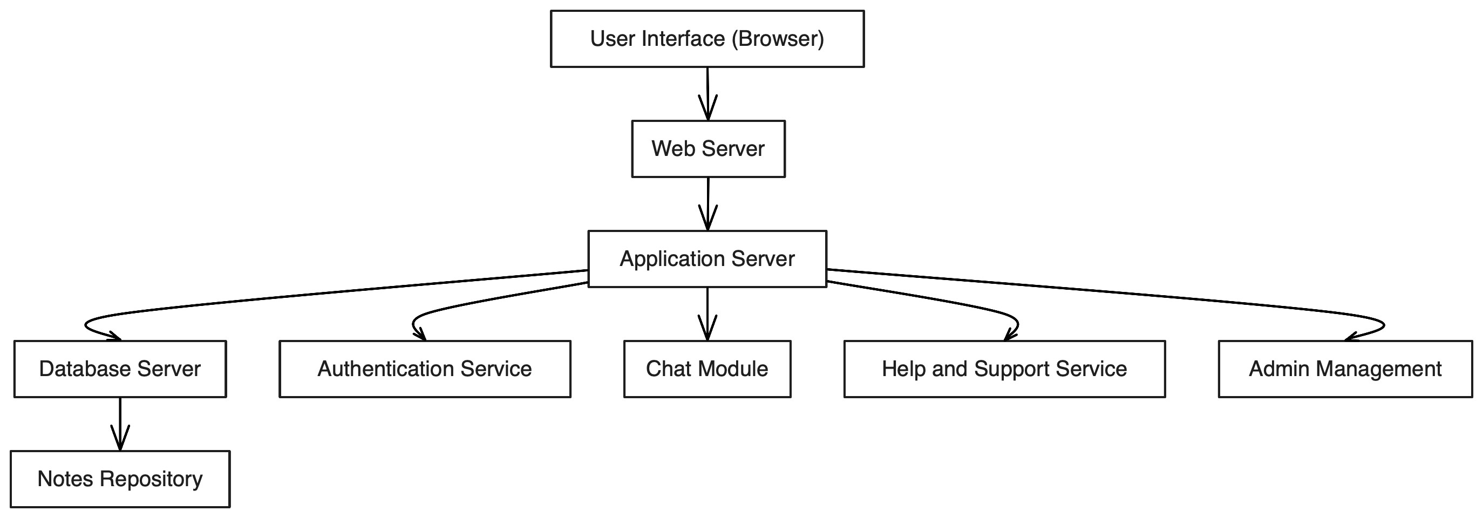

The technical architecture of the Comprehensive Digital Learning System includes the following components:

* **Frontend**: The user interface, developed using modern web technologies like HTML, CSS, and JavaScript frameworks
* **Backend**: Server-side logic handled by a backend framework that processes requests and communicates with the database.
* **Database**: A relational or NoSQL database (e.g., MySQL, MongoDB) for storing user data, course content, and other relevant information.
* **API**: RESTful APIs to facilitate communication between the frontend and backend.
* **Security**: Implementation of security protocols such as HTTPS, SSL/TLS, and authentication mechanisms (e.g., OAuth) to protect user data.
* **Hosting**: Deployment on cloud services (e.g., AWS, Azure) for scalability and high availability.

### 3.2 Sequence Diagrams

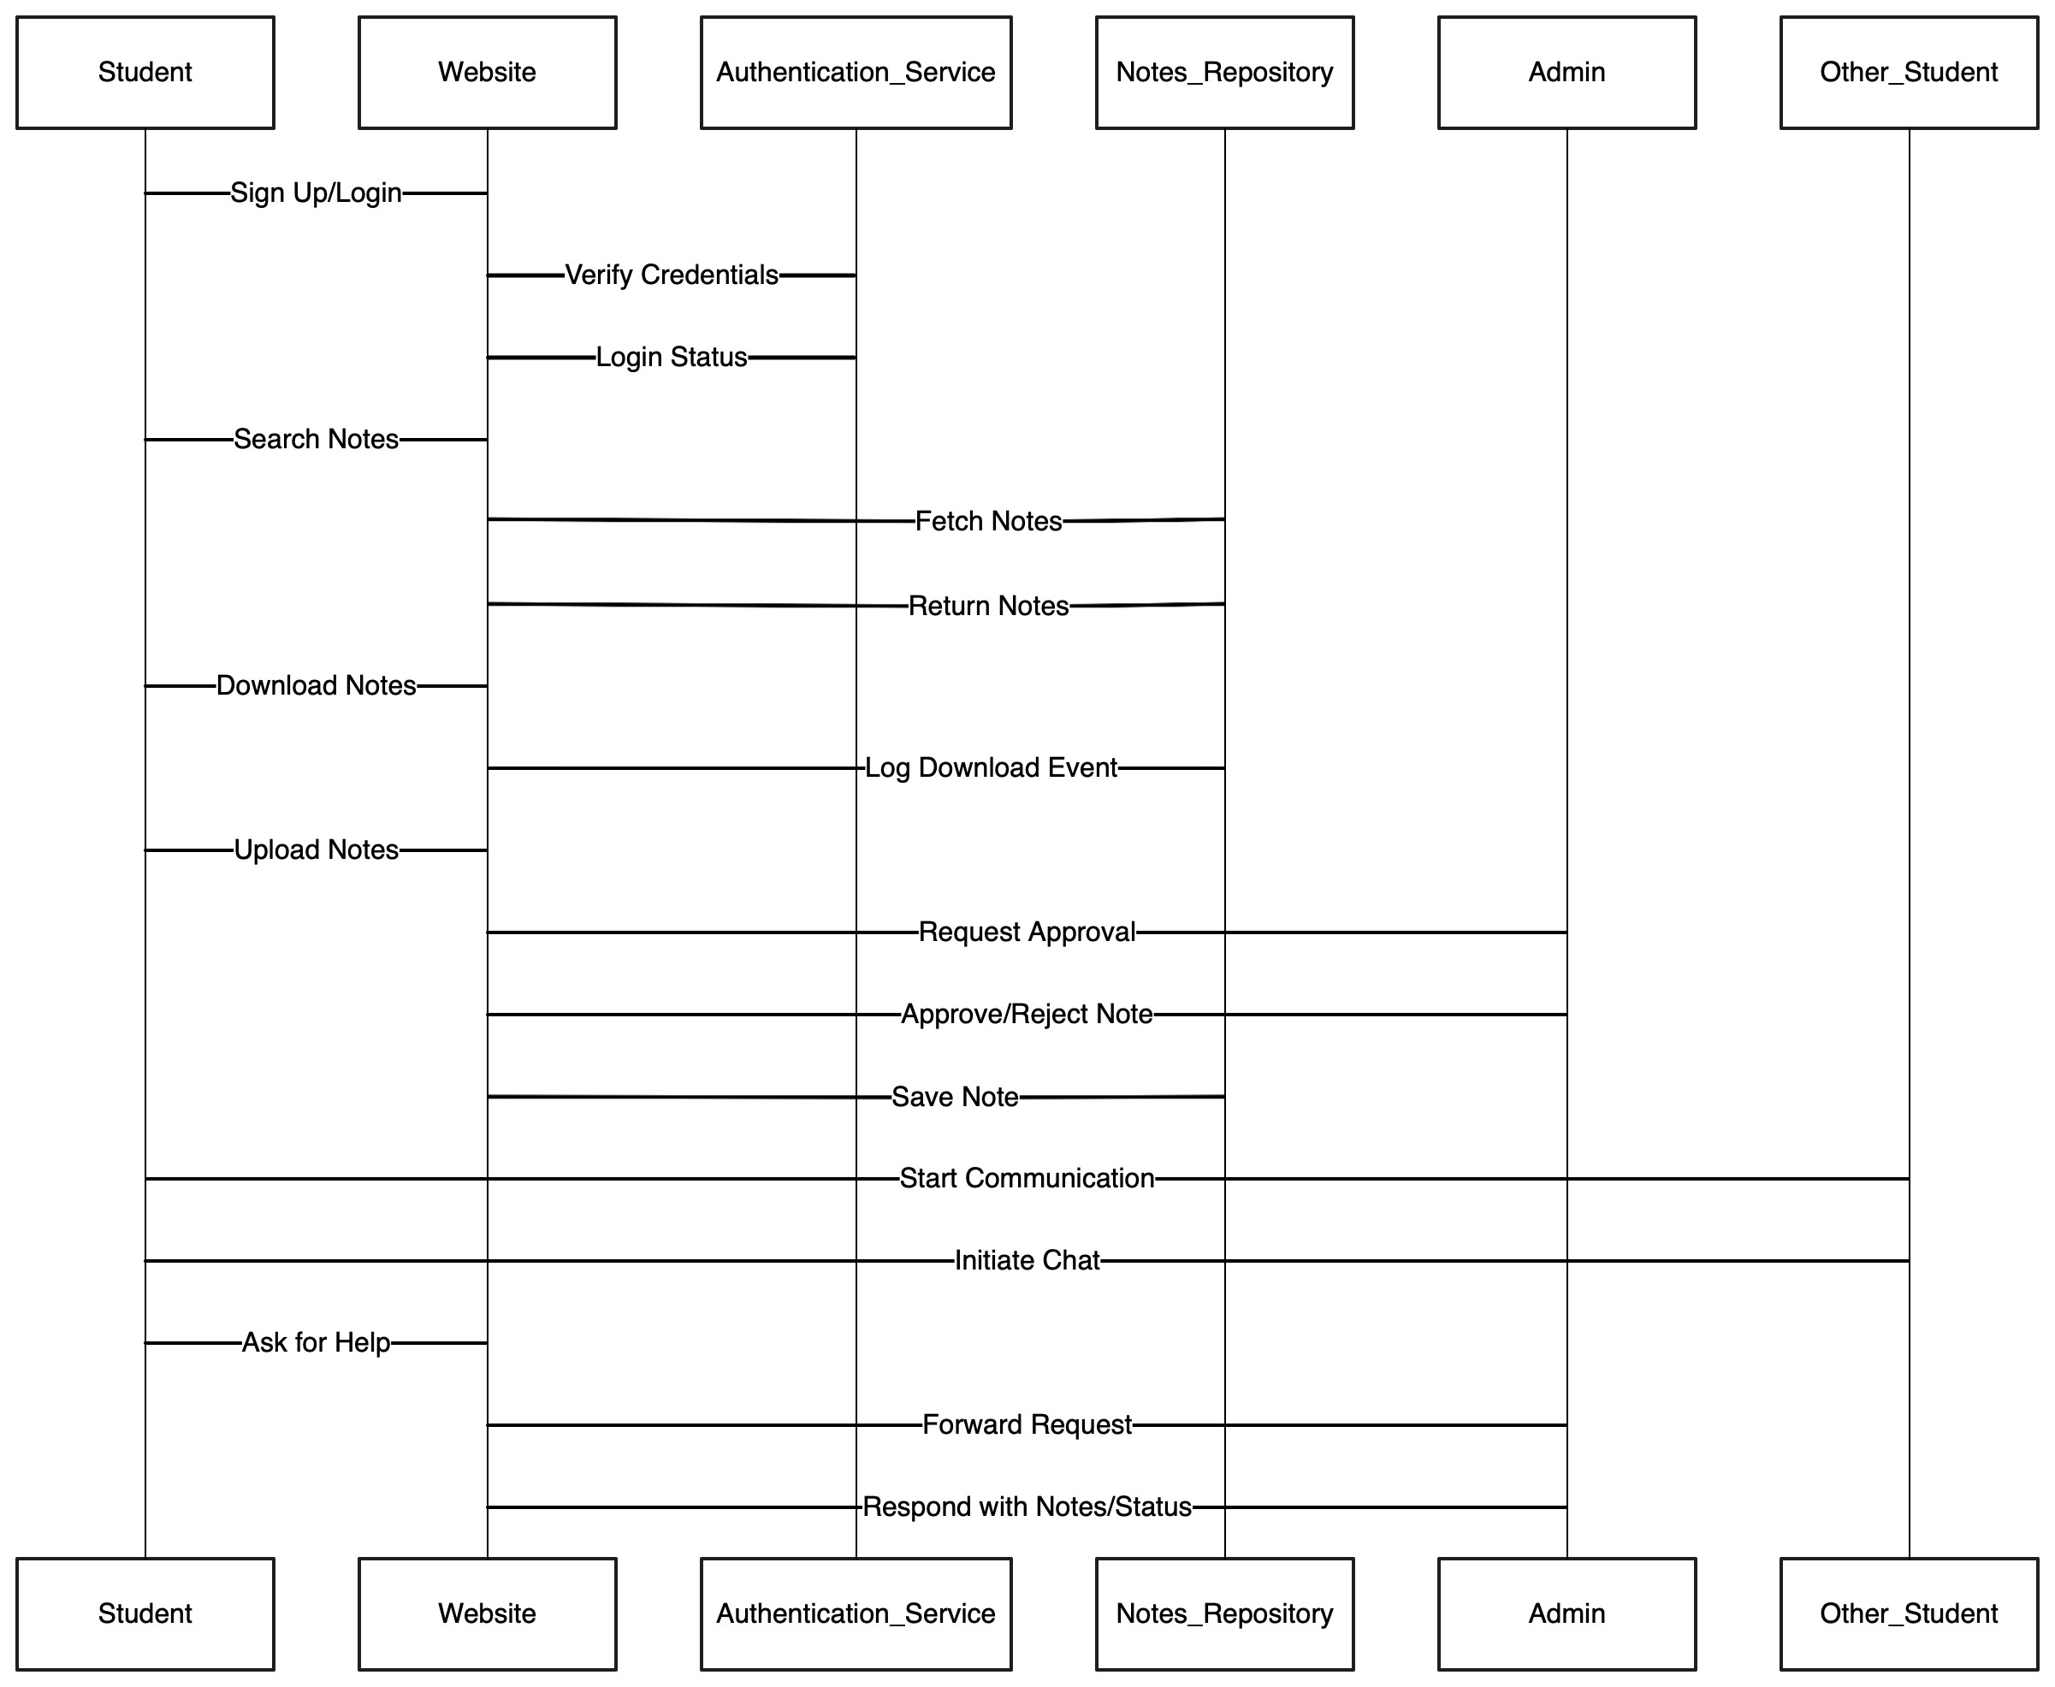

Sequence diagrams illustrate the interactions between different system components and actors over time. Key sequence diagrams include:

* **User Login Sequence**: Steps involved when a user logs into the system.
* **Course Enrollment Sequence**: The process of a student enrolling in a course.
* **Content Access Sequence**: How a student accesses course content.

### 3.3 Class Diagrams

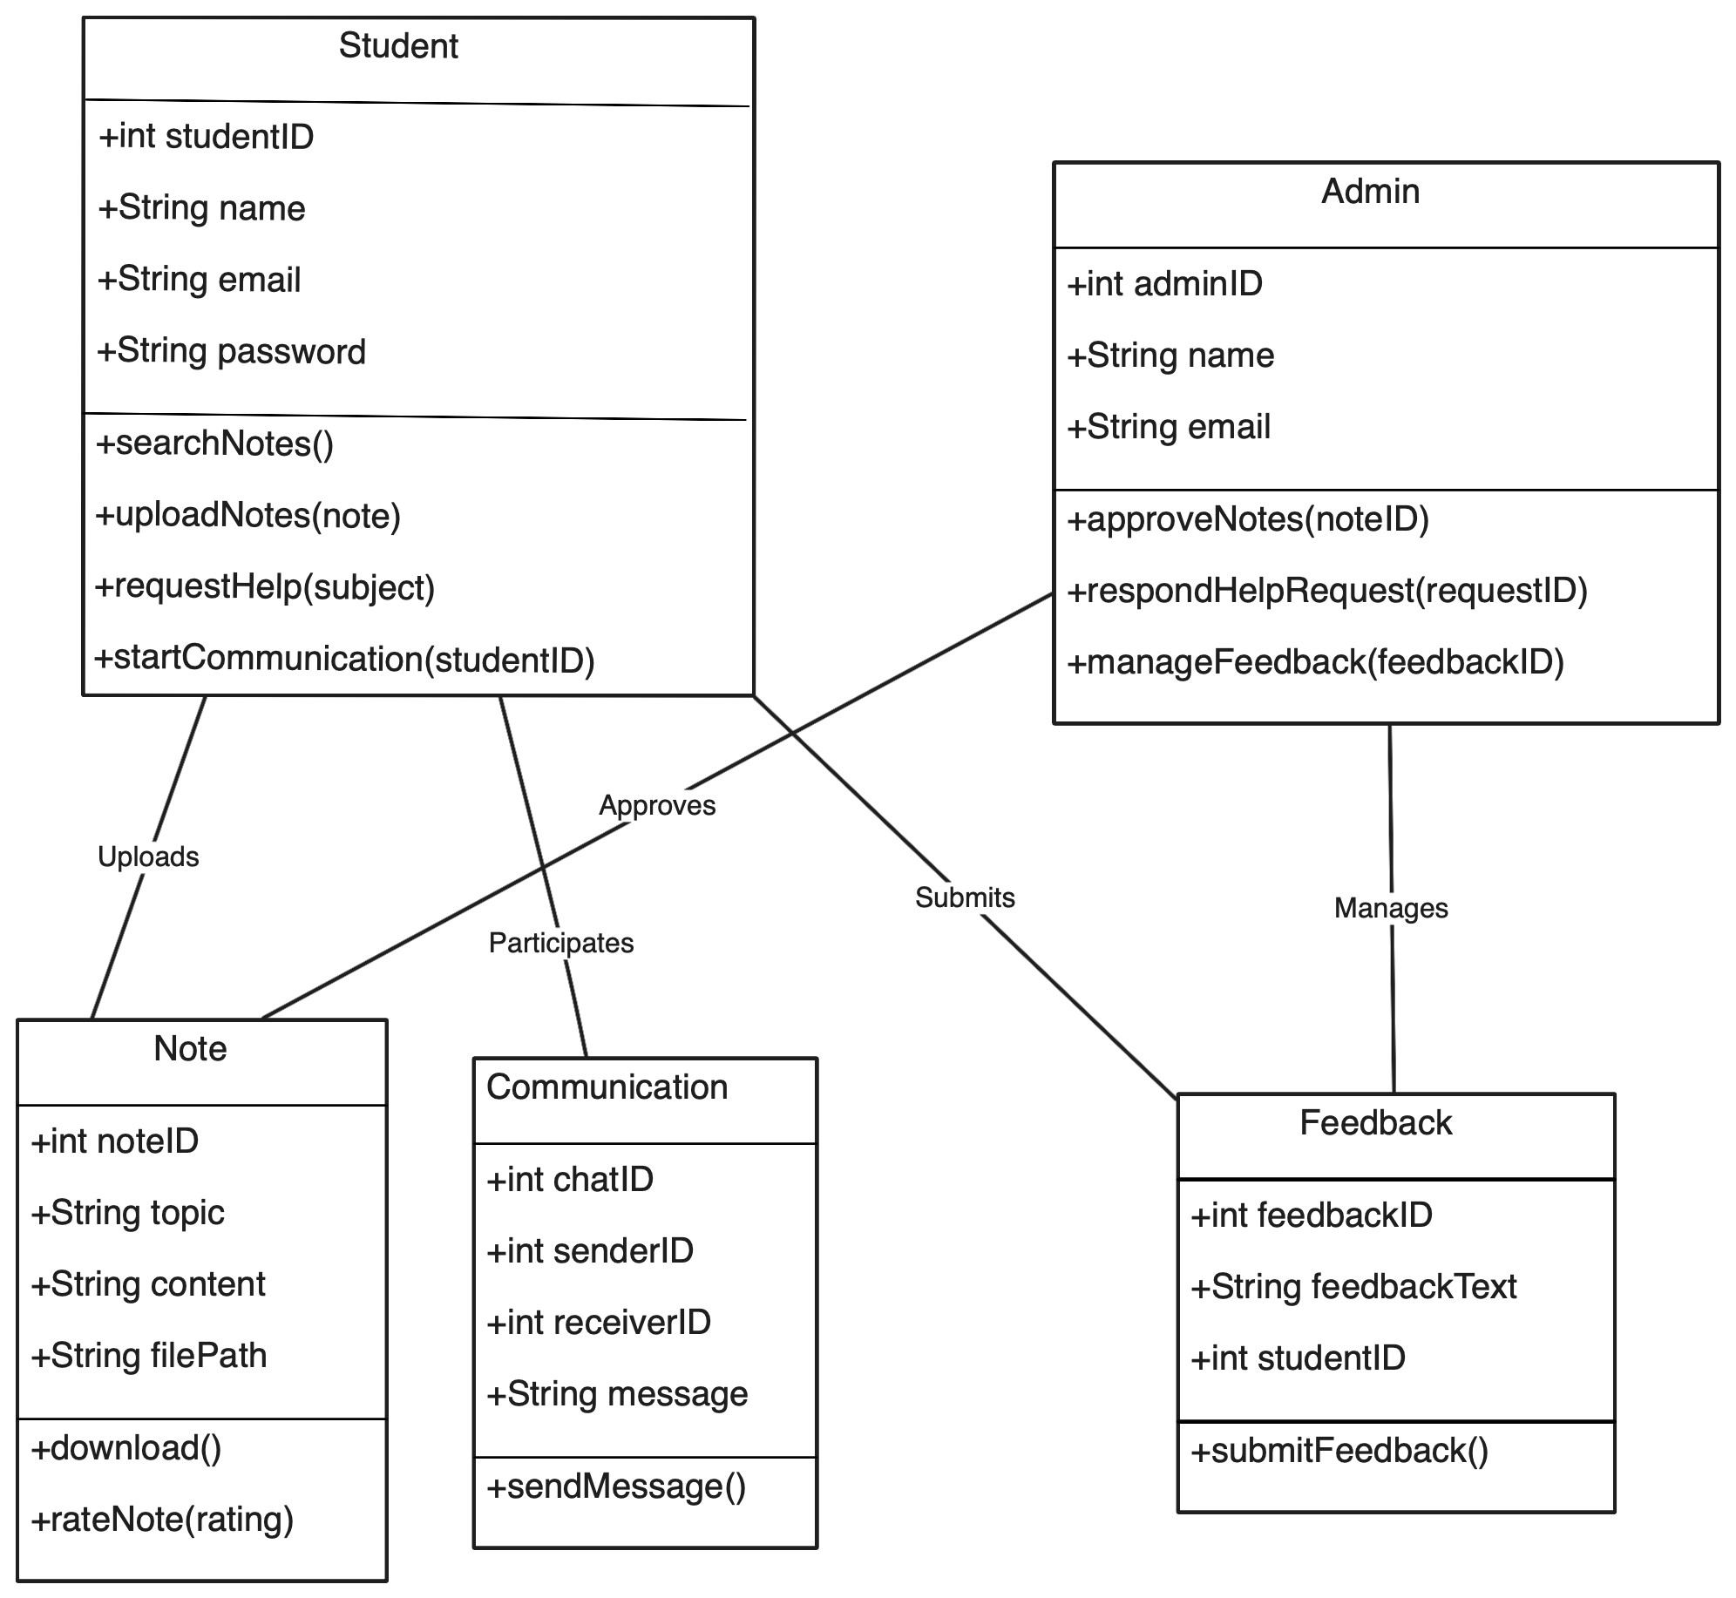

Class diagrams show the structure of the system by depicting the system's classes, their attributes, methods, and relationships. Important classes include:

* **User**: Attributes like userID, name, email, and role; methods for authentication, profile update.
* **Course**: Attributes like courseID, title, description; methods for adding, updating, and deleting courses.
* **Assessment**: Attributes like assessmentID, type, questions; methods for creating, grading assessments.
* **Discussion**: Attributes like discussionID, topic, posts; methods for adding, deleting, and viewing posts.

### 3.4 Data Flow Diagrams (DFD)

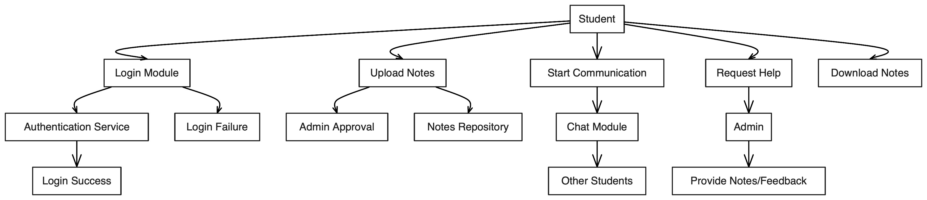

DFDs represent the flow of data within the system. They can be depicted at various levels:

* **Level 0 (Context Diagram)**: Shows the system as a whole and its interaction with external entities (e.g., users, external databases).
* **Level 1**: Breaks down the main processes within the system into sub-processes (e.g., user authentication, content management).

### 3.5 User Interface Design

The user interface design focuses on creating an intuitive and user-friendly experience. Key aspects include:

* **Navigation**: Clear and consistent navigation menus.
* **Responsive Design**: Ensuring the system is accessible on various devices (desktops, tablets, smartphones).
* **Accessibility**: Incorporating features like screen reader compatibility and keyboard navigation.
* **Visual Design**: Using appealing visual elements and layouts to enhance user engagement.

### 3.6 Data Design

The data design outlines how data is stored and managed within the system.

**3.6.1 Schema Definitions:**

* **Users Table**: Columns for userID, name, email, passwordHash, role, etc.
* **Courses Table**: Columns for courseID, title, description, instructorID, etc.
* **Assessments Table**: Columns for assessmentID, courseID, type, questions, etc.
* **Discussions Table**: Columns for discussionID, courseID, topic, posts, etc.

**3.6.2 Entity-Relationship (E-R) Diagram:**

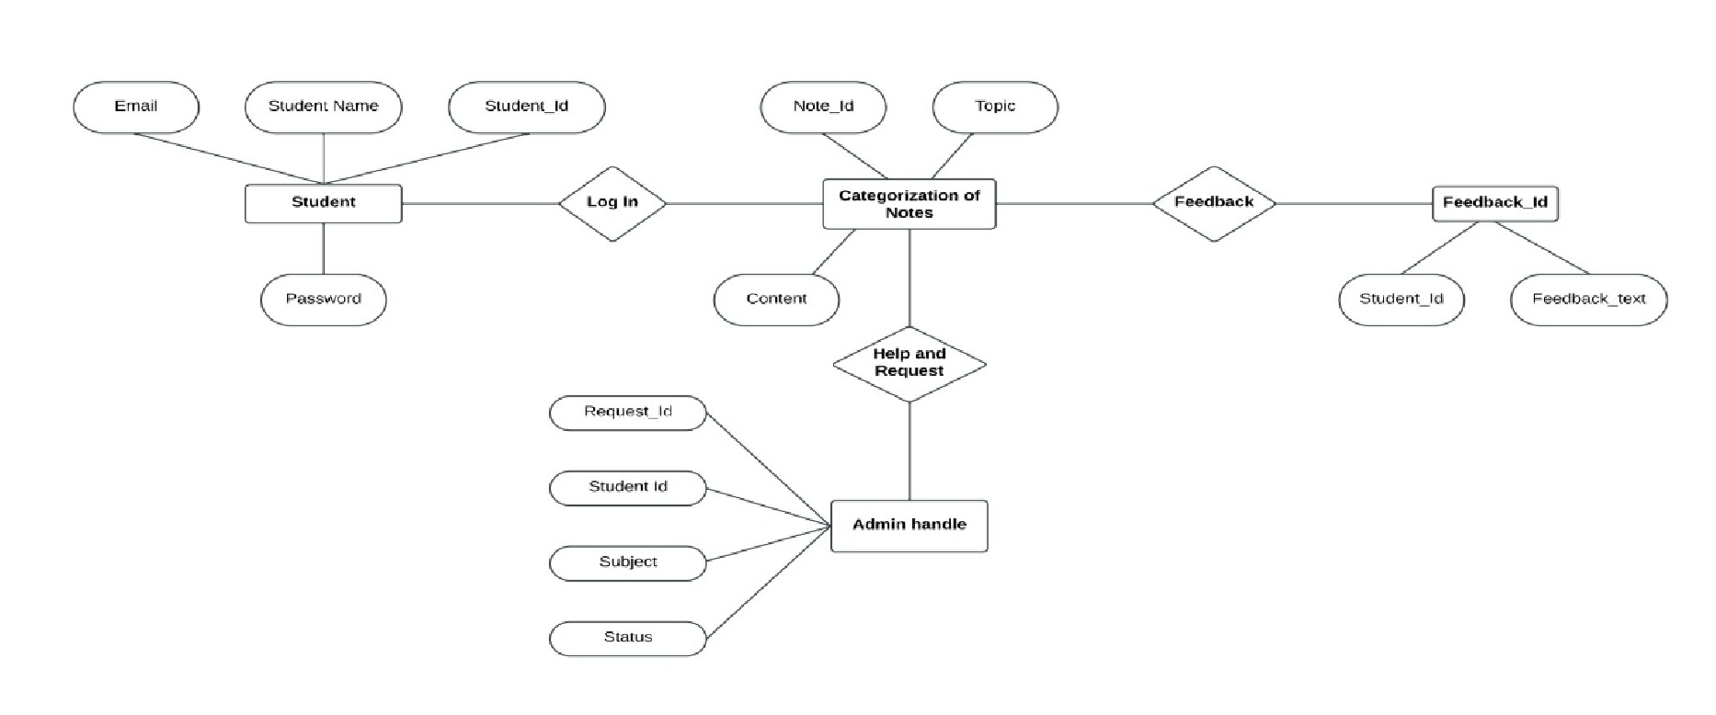

* **Entities**: Users, Courses, Assessments, Discussions.
* **Relationships**:

o A User can enroll in multiple Courses (many-to-many relationship). o A Course can have multiple Assessments (one-to-many relationship). o A Course can have multiple Discussions (one-to-many relationship).

## Chapter 4: Implementation & Testing

### 4.1 Methodology

The project follows an Agile development methodology, focusing on iterative development, continuous feedback, and adaptive planning. This approach ensures flexibility, quicker releases, and the ability to respond to changes efficiently.

**4.1.1 Proposed Algorithm:**

1. **Personalized Content Recommendation:**

* **Input**: Student's performance data, learning preferences, and interaction history.
* **Process**:
* Analyze the input data using machine learning algorithms.
* Identify patterns and learning gaps.
* Generate personalized content recommendations.
* **Output**: A list of tailored educational resources and activities.

### 4.2 Implementation Approach

The implementation approach includes selecting appropriate languages, tools, and technologies for developing the digital learning system.

**4.2.1 Introduction to Languages, IDEs Tools and Technologies:**

* **Languages**:
  + **Frontend**: HTML, CSS, JavaScript, React.js o **Backend**: Node.js, Python, Django
  + **Database**: SQL (MySQL), NoSQL (MongoDB)
* **IDEs**: Visual Studio Code, PyCharm, IntelliJ IDEA
* **Tools and Technologies**:
  + **Version Control**: Git, GitHub o **Project Management**: JIRA, Trello o **APIs**: RESTful services, GraphQL o **Testing Tools**: Selenium, Jest, JUnit
  + **Deployment**: AWS, Docker, Kubernetes

### 4.3 Testing Approaches

Testing is a critical phase to ensure the system functions as intended and meets user requirements. Two primary testing approaches used are unit testing and integration testing.

**4.3.1 Unit Testing:**

* **a. Test Cases:**
  + **Test Case 1**: Verify user login functionality
    - * **Input**: Valid and invalid credentials
      * **Expected Output**: Successful login for valid credentials, error message for invalid credentials
  + **Test Case 2**: Validate course enrollment process
    - * **Input**: Student selects a course
      * **Expected Output**: Student is enrolled in the selected course
  + **Test Case 3**: Check content access
    - * **Input**: Student tries to access course materials
      * **Expected Output**: Course materials are accessible to the enrolled student

**4.3.2 Integration Testing:**

* **b. Test Cases:**
  + **Test Case 1**: Verify integration between user authentication and course management
    - * **Scenario**: Logged-in user enrolls in a course
      * **Expected Output**: User's course enrollment status is updated, and course content is accessible
  + **Test Case 2**: Validate interaction between assessment module and progress tracking
    - * **Scenario**: Student completes an assessment
      * **Expected Output**: Assessment results are recorded, and progress tracker is updated
  + **Test Case 3**: Check data flow between frontend and backend
    - * **Scenario**: User performs various actions (e.g., viewing courses, submitting assignments)
      * **Expected Output**: Data is accurately transmitted and processed between frontend and backend

## Chapter 5: Results & Discussion

### 5.1 User Interface Representation

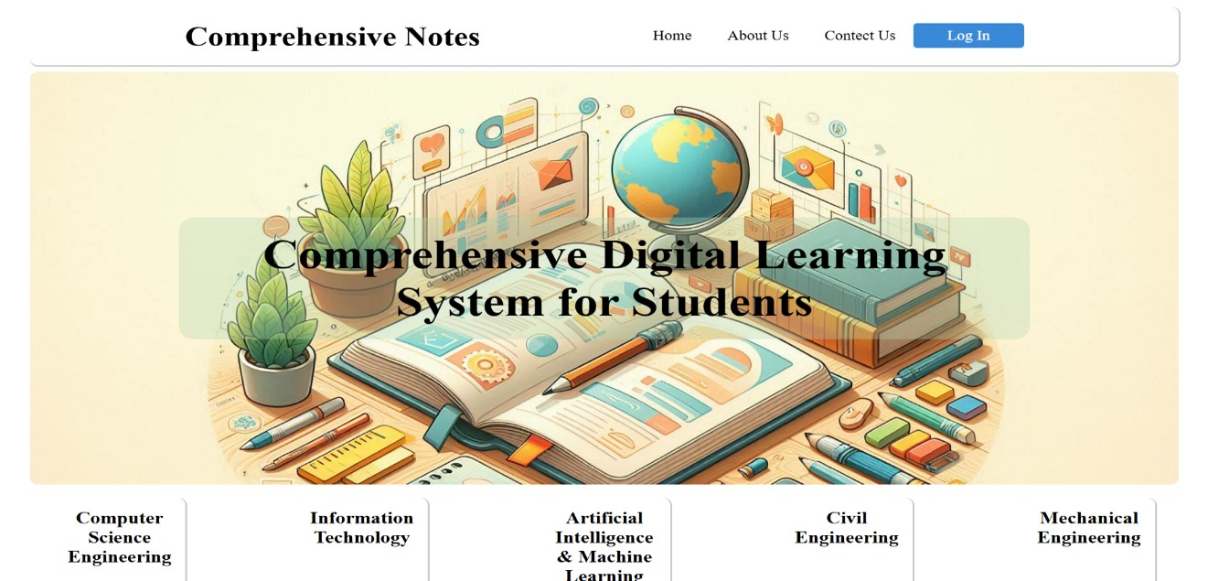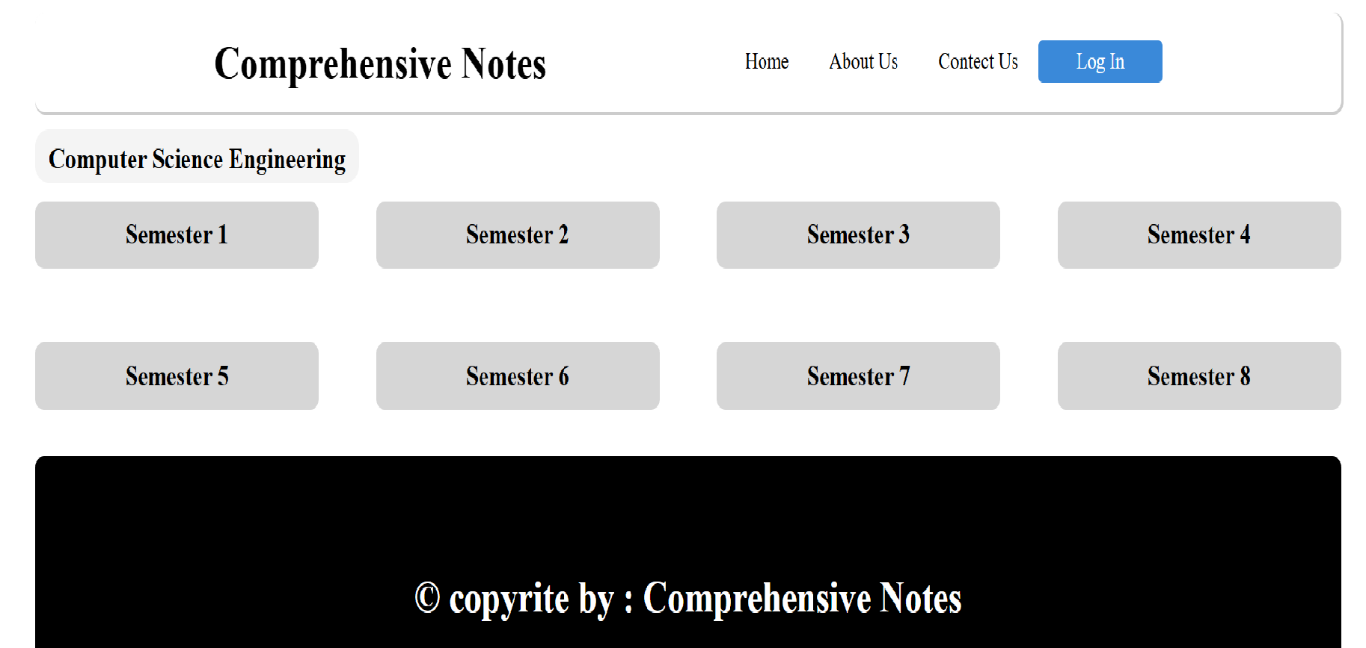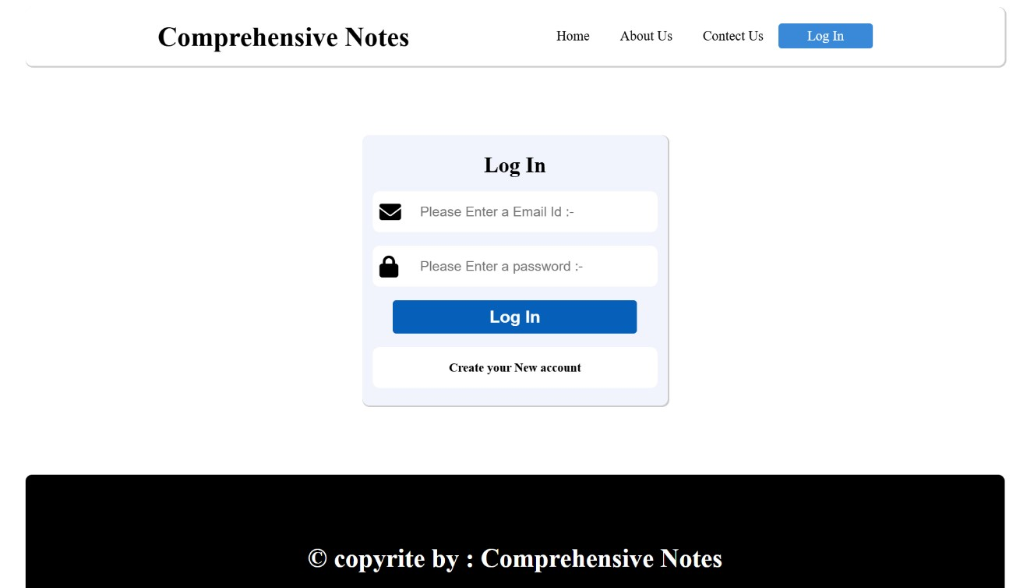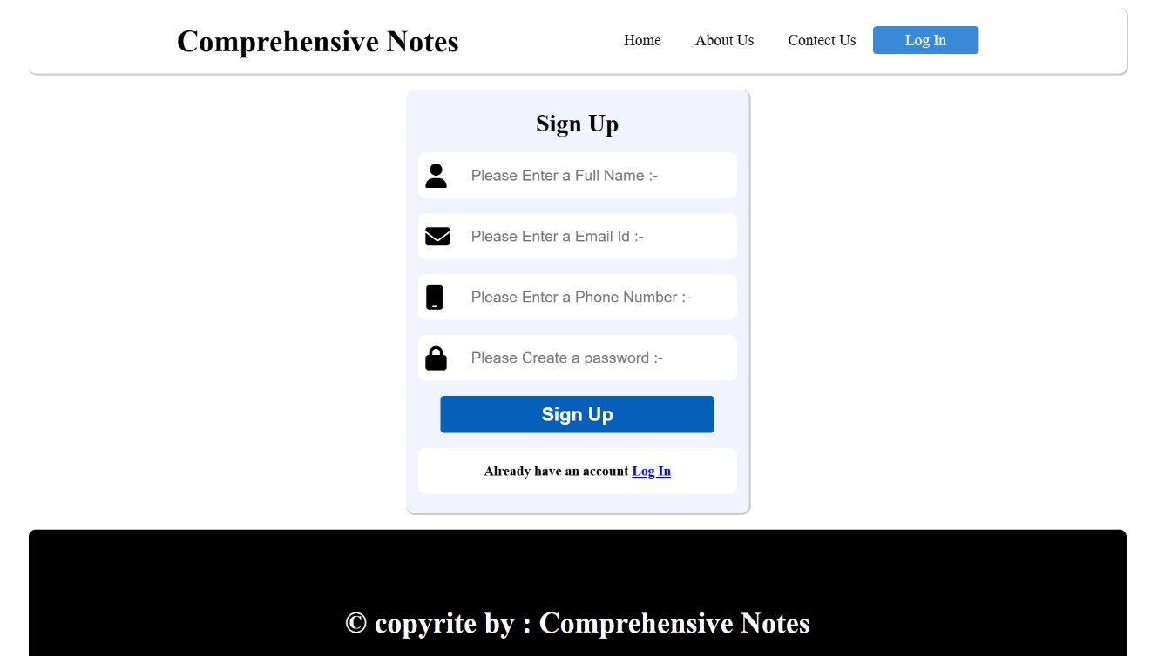

The User Interface (UI) of the Comprehensive Digital Learning System for Students is designed to be intuitive, engaging, and user-friendly. It ensures that students can easily navigate through the platform and access the necessary resources for their learning.

#### 5.1.1 Brief Description of Various Modules

* **Dashboard**: Provides an overview of the student’s progress, upcoming assignments, and announcements.
* **Courses**: Displays a list of courses the student is enrolled in, with links to course materials, lectures, and assignments.
* **Assessments**: A dedicated section for quizzes, tests, and assignments, where students can attempt assessments and view results.
* **Discussion Forums**: Allows students and educators to discuss course-related topics, ask questions, and collaborate on projects.
* **Profile**: Enables students to update personal information, view their progress, and track achievements.
* **Notifications**: Alerts students about important updates, deadlines, and messages from educators.

### 5.2 Snapshot of System with Brief Description

The snapshots of the system provide a visual representation of how the digital learning platform looks and operates. These include:

* **Login Page**: A simple and secure login interface.
* **Dashboard**: Overview of the student’s activities and progress.
* **Course Page**: Detailed view of course materials and lectures.
* **Assessment Page**: Interface for attempting quizzes and assignments.
* **Discussion Forum**: Collaborative space for student and educator interactions.

### 5.3 Database Description

The database is structured to store all relevant data securely and efficiently. It includes tables for users, courses, assessments, discussions, and notifications.

#### 5.3.1 Snapshot of Database Tables with Brief Description

* **Users Table**: Stores user information such as userID, name, email, passwordHash, and role.
* **Courses Table**: Contains course details including courseID, title, description, and instructorID.
* **Assessments Table**: Keeps records of assessments with assessmentID, courseID, type, and questions.
* **Discussions Table**: Manages discussion forums with discussionID, courseID, topic, and posts.
* **Notifications Table**: Tracks notifications with notificationID, userID, and message.

### 5.4 Final Findings

The implementation of the Comprehensive Digital Learning System for Students demonstrated significant improvements in student engagement and learning outcomes. Key findings include:

* **Enhanced Engagement**: Students were more engaged with interactive content and personalized learning paths.
* **Improved Performance**: There was a noticeable improvement in test scores and assignment submissions.
* **Positive Feedback**: Both students and educators provided positive feedback on the system’s usability and effectiveness.
* **Operational Efficiency**: Educators reported reduced administrative workload, allowing more focus on teaching.

## Chapter 6: Conclusion & Future Scope

### 6.1 Conclusion

The development of a Comprehensive Digital Learning System for Students marks a significant step toward modernizing education by integrating technology to create an inclusive, flexible, and engaging learning environment. This system bridges gaps in traditional learning methods by offering personalized learning experiences, real-time performance analytics, and interactive content tailored to diverse learning styles. The platform has demonstrated its potential to improve knowledge retention, accessibility, and collaborative learning opportunities, ensuring that education is more effective and equitable.

### 6.2 Future Scope

The future scope of the Comprehensive Digital Learning System is vast, with several areas for enhancement and expansion:

* **Scalability**: Expanding the system to support a larger number of users and institutions, ensuring high performance and reliability.
* **Advanced Analytics**: Integrating more sophisticated analytics tools to provide deeper insights into student performance and learning patterns.
* **Multilingual Support**: Adding support for multiple languages to cater to a diverse student population globally.
* **Mobile Applications**: Developing dedicated mobile applications to enhance accessibility and provide a seamless learning experience on-the-go.
* **Enhanced Collaboration Tools**: Introducing more advanced collaborative features such as real-time document editing, virtual classrooms, and video conferencing.
* **Continuous Improvement**: Regularly updating the system based on user feedback and emerging educational trends to ensure it remains relevant and effective.

**REFERENCES**

1. Digital Tools, Technologies, and Learning Methodologies for Education 4.0

Frameworks: A STEM Oriented Survey. Retrieved from

<https://ieeexplore.ieee.org/document/10401932>

1. Google Scholar (2024). *Academic Papers and Theses on Digital Learning Systems*. Retrieved from [https://scholar.google.com/.](https://scholar.google.com/)

1. Kumar, V., & Sharma, S. (2021). *E-Learning System for Education 4.0: Concept and Challenges*. *International Journal of Emerging Technologies in Learning (iJET)*. Retrieved from [https://online-journals.org/.](https://online-journals.org/)

1. JSTOR (2023). *A Digital Library for Academic Journals, Books, and Primary Sources on Educational Technology*. Retrieved from [https://www.jstor.org/.](https://www.jstor.org/)

1. Mozilla Foundation (2024). *MDN Web Docs: Web Development Guides and*

*Tutorials*. Retrieved from [https://developer.mozilla.org/.](https://developer.mozilla.org/)

1. UNESCO (2023). *Digital Education Systems for Sustainable Learning Environments*. Retrieved from [https://unesdoc.unesco.org/.](https://unesdoc.unesco.org/)

1. Smith, J., & Anderson, K. (2022). *Learning Analytics in Digital Classrooms: Transforming Education Through AI*. Springer Publications. Retrieved from [https://link.springer.com/.](https://link.springer.com/)

1. EdTech Magazine (2024). *Leveraging AI and Gamification in E-Learning Platforms*. Retrieved from [https://edtechmagazine.com/.](https://edtechmagazine.com/)

1. IEEE Xplore (2024). *Machine Learning Applications in Adaptive E-Learning Platforms*. Retrieved from [https://ieeexplore.ieee.org/.](https://ieeexplore.ieee.org/)
2. T. Johnson & R. Patel (2021). *The Role of Cloud Computing in Modern Digital Learning Systems*. *Journal of Digital Learning Technology*, 15(3), 112-118. Retrieved from [https://journals.sagepub.com/.](https://journals.sagepub.com/)

1. Khan Academy (2023). *Developing Personalized Learning Systems for Students*. Retrieved from [https://www.khanacademy.org/.](https://www.khanacademy.org/)

1. MIT OpenCourseWare (2024). *Innovations in Digital Education Systems*. Retrieved from [https://ocw.mit.edu/.](https://ocw.mit.edu/)

1. Prasad, K., & Mehta, R. (2023). *The Importance of Peer Review and Collaboration in E-Learning Platforms*. *Educational Technology Research and Development*. Retrieved from [https://link.springer.com/.](https://link.springer.com/)

1. GitHub Docs (2024). *Developing Scalable E-Learning Platforms Using OpenSource Tools*. Retrieved from [https://docs.github.com/.](https://docs.github.com/)

1. Oracle Cloud (2023). *Using Cloud Technology for Scalable E-Learning Platforms*. Retrieved from [https://www.oracle.com/.](https://www.oracle.com/)

**Appendix A:** Project Synopsis https://github.com/Atharv9406/Minor-Project/blob/main/Synposis%20Final.docx

**Appendix B:** Guide Interaction Report

**Appendix C:** User Manual

**Appendix D:** Git/GitHub Commits/Version History